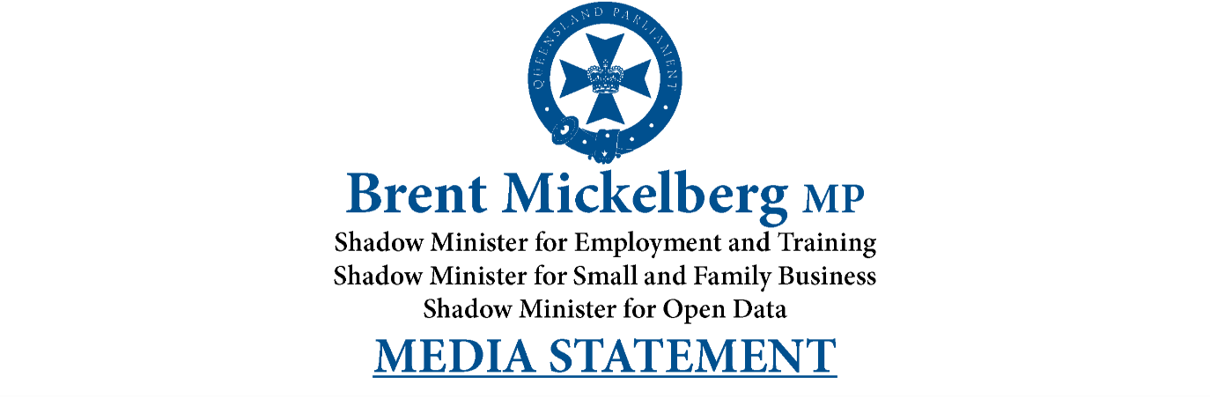
No Excuse for Speeding Drivers in School Zones
Flashing 40km/h signs have been installed near Chancellor State College and the Palmview school precinct as a warning to drivers to slow down.
Recent data shows 36,507 Queensland drivers were fined for speeding in school zones between 2021 and September last year, some caught driving more than double the speed limit.
Member for Buderim Brent Mickelberg says he is happy to see the signs installed after years of advocacy.
“It’s better late than never. I had approached the former Main Roads Minister on many occasions to have these signs installed. The safety of our children should be top priority,” Mr Mickelberg said.
“Our community continues to grow rapidly and with that comes the need to improve road safety around our local schools.
“There were almost 10-thousand drivers caught speeding in Queensland school zones last year up to September. That’s a scary number when we’re talking about the lives of children.”
Division 6 Councillor Christian Dickson said he had received many requests from locals to improve traffic safety.
“Residents have asked for improved visibility and better enforcement of the 40km/h school zone along Peter Crosby Way,” Cr Dickson said.
“There is a large desire to see vehicle speeds reduced to improve safety around our school precincts, and these signs will greatly assist.”
-ENDS-

